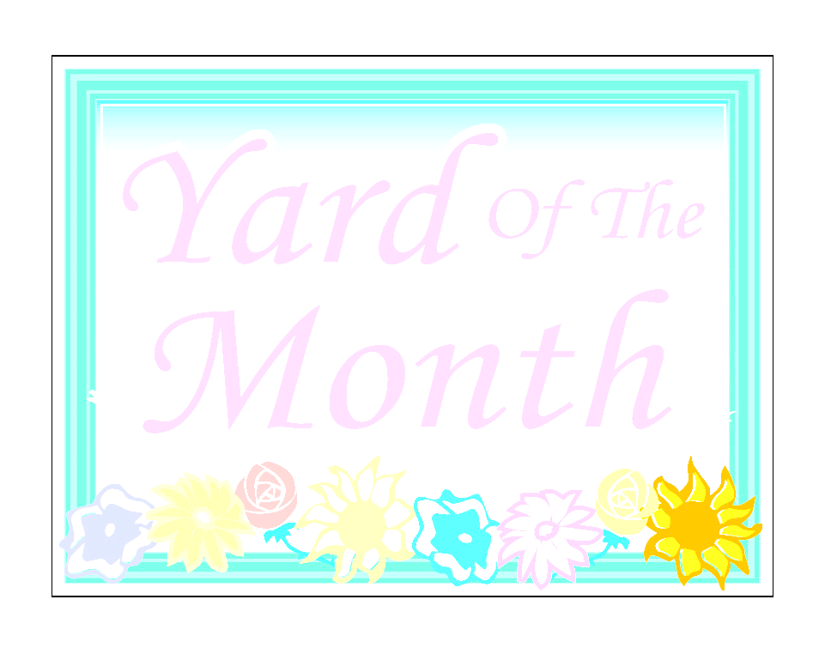***Ravencrest Home Owners Association***

***Yard of the Month Rules and Criteria***

***“Yard of the Month is recognition for maintaining a beautiful yard on a consistent basis.”***

**As many citations handed out in 2016-17, were for yard issues, your RHOA BOD would like to give an incentive to maintaining a vibrant appearance of the neighborhood.**

**The Yard of the Month Program will be managed by the RHOA BOD in accordance with the RHOA Covenants. Each month from April to December the Yard of the Month (YOM) Committee will nominate no more than two (2) houses for a “Winner” and “Runner-Up.” The rules will be reviewed for possible changes at the end of each competition year based on the results of that year.**

**Rules:**

1. The RHOA Board of Directors (***at minimum three***): President, Vice President, Secretary, Treasurer, Architecture Committee, and At-Large Member will judge yards.
2. Judging will take place the last week of the month for the following month’s winner (week of November 30th, for December recognition).
3. Judging will take place April thru December.

*\*October and November will be judged on fall color. *December will be the Holiday decorating contest.*

1. The homeowner must be in good standing with the Home Owners Association dues and no violations of Bylaws and/or Covenants.
2. Homeowners Association Board members are not eligible to win recognition.
3. Each month of recognition, there will be a Yard of the Month “Winner” and a “Runner-Up.”
4. No resident may receive Yard of the Month more than once in any calendar year.
5. Yard of the Month sign will be placed in the yard on the 1st day of the month and placed where it is most visible from the street. The Winner will be acknowledged in the Ravencrest Newsletter and on the Ravencrest HOA website along with a picture. Winners will also receive $25.00 gift card to Lowe’s or Home Depot (winner’s preference).

**Criteria:**

* Owner must be in Good Standing with the Association (dues, no citation, or violations).
* Lawn must follow authorized landscape in Architectural Guidelines
* Lawn -mowed, trimmed, and weed-free. Edging- driveway, walks, and curbs.
* Shrubs, Bushes, and Trees- healthy, neatly pruned, in proportion/scale with home and terrain
* Unique landscaping or originality/creativity (especially coverage of unsightly pipes, etc.)
* Pleasant and overall appearance which makes the property an asset to the community
* Front yard to midpoint sides of yard will be judged
* Color (green grass, colorful alive plants, mulch, other landscape design material, etc.)
* House and driveway appearance clean (no unsightly debris, broken gutters, bent mailbox, etc.)
* Yard of the Month will be awarded end of April to end of December.
* Two (2) homes will be selected during each month (Winner & Runner-Up)

Ravencrest HOA Board